|  |
| --- |
|  |
| SolutionSelling GitLab PCF - CHG0304876 - Install and Roll Back Instructions |
| FY21 DCS0103 |
| Application names:  Troux ID :  Document Owner: Vivian Chang  Document Reviewer: SolutionSellingKoenseigg  Document Version: V1  Date of release – 1/13/2021  CHG0304876 |
|  |
|  |

|  |
| --- |
| This document is designed to provide the information needed to perform production deployment to PCF Production Servers. |

SolutionSelling

Contents

1 Pre-requisites 2

1. Access to GitLab 2

2. Verify the change ticket 2

2 Deployment 3

2.2 Deployment Details 3

2.2.1 SolutionSelling 3

2.3 PRODUCTION – Deployment on PCF (S3B & PC1) 4

2.3.1 EnterpriseSolutions 4

2.4 Deployment Errors 5

2.5 Rollback 5

2.6 Inflight Changes 5

# Pre-requisites

## Access to GitLab

1. Login to <https://gitlab.dell.com/seller/SolutionSelling>
2. If you are not able to login with above URL, please reach out to SolutionSellingKoenigsegg [SolutionSellingKoenigsegg@Dell.com](mailto:SolutionSellingKoenigsegg@Dell.com) to get access.

## Verify the change ticket

1. Open Dell Service Management – [http://dell.service-now.com](http://dell.service-now.com/)
2. In the top right corner, click the magnifying glass
3. Enter CHG0304876 search bar, and hit “enter”

|  |
| --- |
| If you do not complete the above two steps properly you will not be able to deploy to production. |
|  |

# Deployment

# Deployment Details

### SolutionSelling

|  |  |  |  |  |
| --- | --- | --- | --- | --- |
| **Database Name** | **Current Release Date** | **Tag** | **Previous Release Date** | **Rollback Version** |
| EnterpriseSolutions | 01/13/2021 | FY22-0103-V1.0 |  |  |
|  |  |  |  |  |
|  |  |  |  |  |
|  |  |  |  |  |
|  |  |  |  |  |
|  |  |  |  |  |
|  |  |  |  |  |
|  |  |  |  |  |
|  |  |  |  |  |
|  |  |  |  |  |
|  |  |  |  |  |

# 

# PRODUCTION – Deployment on PCF (S3B & PC1)

### EnterpriseSolutions

1. Go to the pipeline page in GitLab <https://gitlab.dell.com/seller/SolutionSelling/ops-and-tools/utilities/db/enterprisesolutions/pipelines>
2. Click the “Run Pipeline” button.

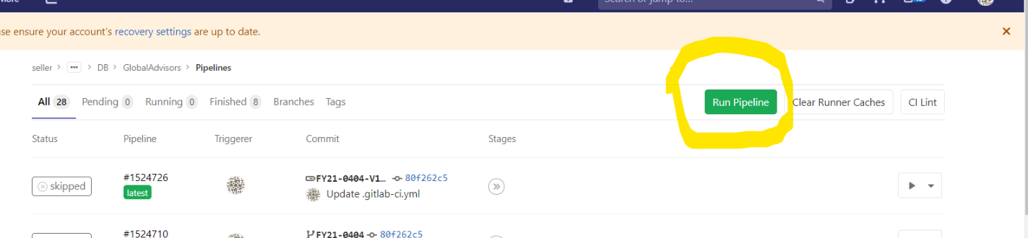

1. On the subsequent screen, select **FY22-0103-V1.0** from the drop down menu in “Run for” tab. DBA needs to give the adm account and password in the variable menu by giving these details as per below screenshot and then click on “Run Pipeline”

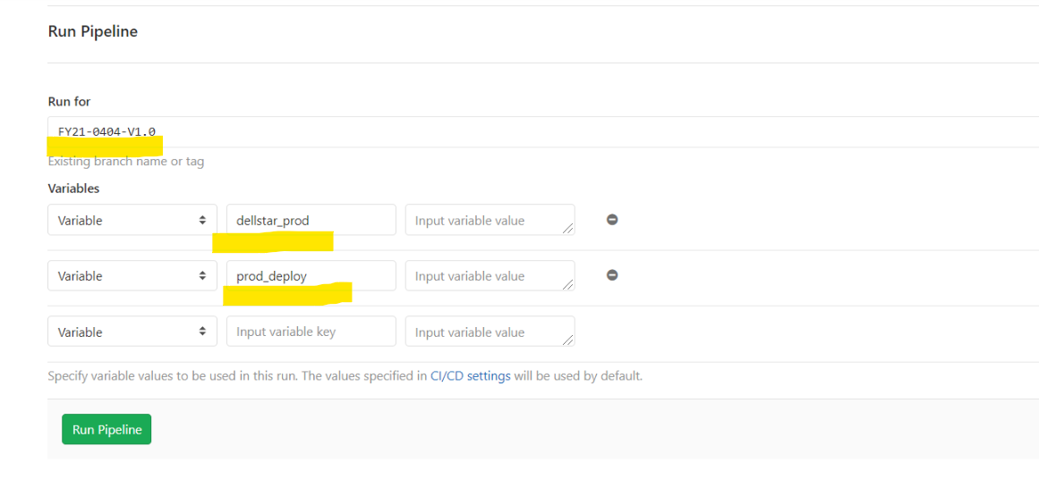

1. The variable section DBA Can give the below varables with value to run the pipeline.

**dellstar_prod : XXXXXX(adm account)**

**prod_deploy: xxxxxxxx(password)**

1. In Deploy-prod, click the PROD-deploy ►button to deploy to production.

f) After successful deployment, it will show green check box. Dev team will verify the changes on production server.

# Deployment Errors

In case a deployment request results in an error, you can try to redeploy. The “Retry” button will be visible in the same request against the server when you refresh the screen.

# Rollback

1. In case of any rollback changes required click the PROD-Rollback ►button to rollback to te previos version.

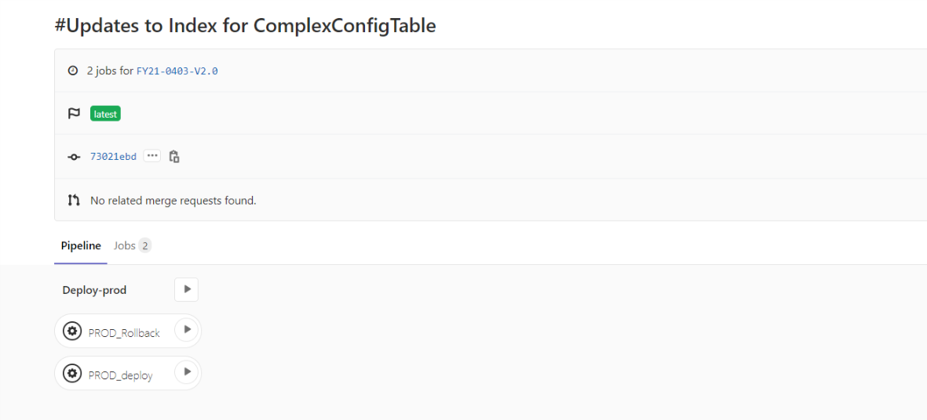

1. After successful deployment, it will show green check box. Dev team will verify the rollback changes on production server

# Inflight Changes